Forage site distributions quantify collective foraging in honey bee colonies

Joseph Palmer, Ash Samuelson, Elli Leadbeater and Vincent Jansen

Alternative title:

* Waggle run durations quantify collective foraging in honey bee colonies
* Waggle run duration distributions quantify collective foraging in honey bee colonies
* Distributions of waggle dance durations quantifies collective foraging in honey bee colonies

Or something like this.

# Abstract

Honeybee foraging is a collective behaviour that is directed through the extraordinary waggle dance communication system, whereby colony foraging effort is allocated through a series of feedback loops. Despite having been described as the most astounding example of non-primate communication, recent evidence suggests that the benefits of using dance information vary across environments and are sometimes even negligible. Yet, because we cannot easily quantify collective foraging, pinpointing which environments promote collective foraging is challenging. Here, we present a mathematical model which allows inferring the proportion of ‘scout’ and ‘recruit’ dances on a hive’s dance floor and quantify collective foraging. By applying this methodology to waggle dance data from twenty hives, we show that dance information may be used less in environments where resources are sparse, potentially because colonies are required to send out more scouts to find food in these circumstances. Our methodology provides a tool to quantify waggle dance use in undisturbed hives at a much larger scale than hitherto has been possible and to identify those ecological conditions that may have driven the evolution of this remarkable collective behaviour.

Needs referencing.

# Main

Within honeybee colonies, a series of simple rules that determine when and how much bees perform the celebrated waggle dance (Box 1) mean that choices between feeding sites occur at the level of the group rather than the individual. For example, because the number of dance circuits performed by a bee on returning from a food source reflects the net energetic benefits of the trip, more of the colony’s workforce will be recruited to the sweeter of two equidistant sources (ref), or the closer of two equally sweet sources (ref), without requiring any individual bee to compare options. This extraordinary system is a key example of how social insect colony behaviour can take on a form extending beyond that of the individual units (Sumpter 2006).

Despite such impressive complexity, in some situations, colonies that are prevented from communicating via dances achieve equal or even greater foraging success than their wild-type counterparts (Sherman and Visscher 2002; Dornhaus et al. 2006; Grüter, Segers, and Ratnieks 2013; Price et al. 2019). This indicates that bees frequently ignore the spatial information in dances.

The prevalent explanation for this apparent redundancy portrays dance-based collective foraging as an evolutionary anachronism that was useful in ancient tropical environments but offers little benefit in modern temperate environments (ref). However, fossil evidence has questioned the long-held assumption that the genus Apis evolved in tropical climates (Kotthoff et al 2013). Moreover, given that dancing comes at a significant time cost (ref), this raises the issue of why all temperate *Apis mellifera* colonies continue to dance. The dual questions of what foraging selection pressures drove the evolution of this uniquely complex collective behaviour, and why it continues to exist, are thus yet to be satisfactorily answered. Empirical studies have shown that honeybee colonies use dance information flexibly in response to their environment, suggesting that bees cease to rely on dance information if it provides little benefit (Price et al. 2019). Thus, identifying those environments whereby modern honeybee colonies forage collectively rather than through individual search is a key step towards understanding dance evolution (ref).

Overall, evidence that colony-level collective foraging offers any benefit over individual search has proved surprisingly hard to come by, mainly because this requires to distinguish scouts from recruits. Scouts are foragers that have located a resource through individual search behaviour, whilst recruits are foragers that have found a forage site by using the information provided in the dance of another bee. Scouting and recruiting are not fixed behavioural categories, because individual bees can engage in both over the course of their foraging lifetime, and foragers can dance on return from any successful trip irrespective of whether they were recruited to the forage site or found it individually. So far, scouts and recruits are distinguished by means of the foragers’ individual search history, which requires following individual bees and is time and labour intensive.

Here, we will use a different approach and develop a model that describes the proportion of foraging trips in which bees act as scouts, and as recruits, within a colony, based on the distribution of foraging distances reported by waggle dancing, encoded as the duration of the run phase of the dance (Frisch 1993). We will use this model to infer the proportion of scouts and recruits on the dance floor from dance data, and to demonstrate the principle, apply this methodology to dance data from a collection of hives in different environments.

To reveal what the distribution of waggle run durations reported on the dance floor look like, and to demonstrate that dances from recruits and scouts lead to different distributions, we simulated honeybees foraging in a landscape where resource patches were randomly placed in the environment. Foragers could locate these under two different strategies: either acting as a scout and locating resources themselves, or following a recruit strategy and locating resources by following a random dance from the dance floor (Fig. 1). As it is known in the simulation which individuals forage under what strategy, we can compare the distributions of foraging distances reported on the dance floor. Figs 1c and 1d show that the shapes of the resource distance distributions for the two types of foraging trips are very different. The distance distribution of the scouts is akin to that of an exponential distribution (Fig. 1 C), which is the nearest neighbour distance distribution for foragers operating in a one-dimensional environment (see methods). The distribution of the distances reported by recruits (Fig. 1 D) is a Rayleigh distribution which is the nearest-neighbour distribution of a two-dimensional environment (**???**) (Pyke 1978) (see Methods).

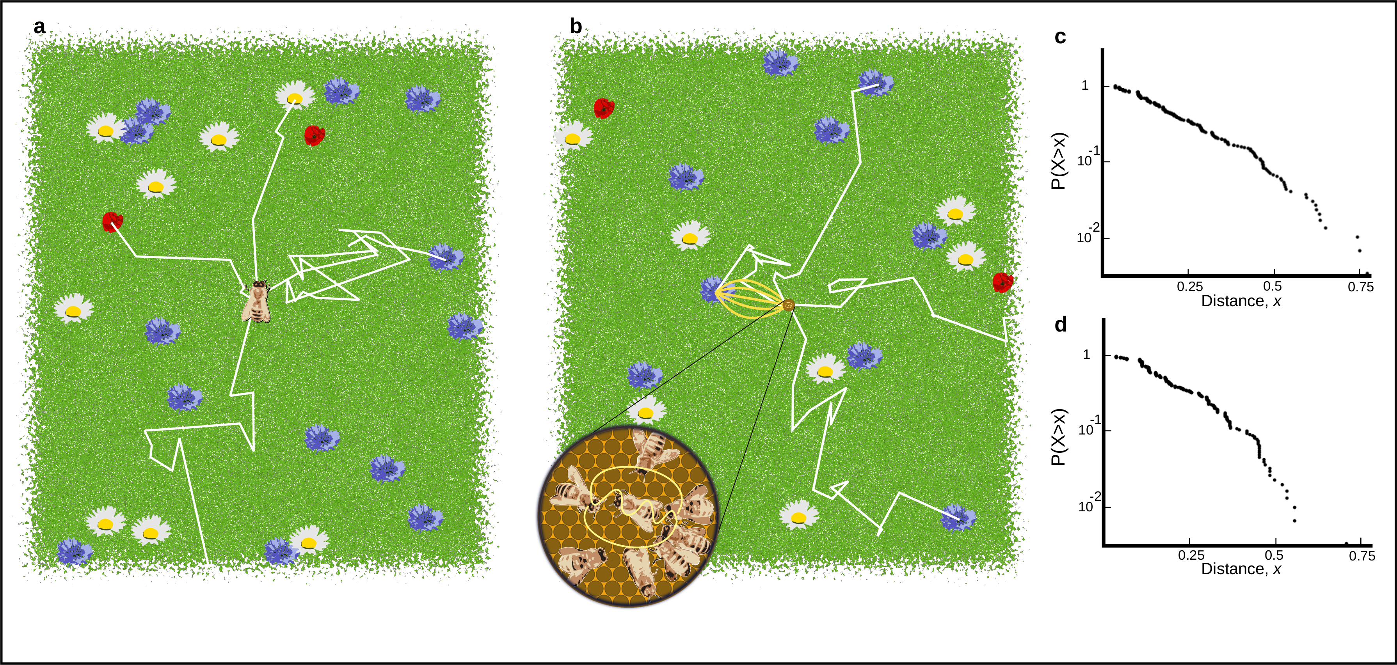

Figure 1. A. Outline of individual foraging. Foragers leave the hive on a random flight path (white lines) and continue until they encounter a resource (flowers in the figure). B. Outline of foraging with recruitment. Some foragers (scouts) continue to identify resources but others (recruits) sample available dances provided by scouts and other recruits. C. Log inverse frequency distribution of foraging distances reported by scouts. D. Log inverse frequency distribution of foraging distances reported by recruits.

Scouts and recruits create different foraging distance distributions on the dance-floor. These different distance distributions can be used to quantify the relative importance of collective foraging. Foragers that scout report a distribution of distances that reflects their probability of encountering a resource in the environment (see methods), whilst foragers that recruits report distances that reflect the distribution of the most profitable resource available (see methods). On the dance-floor, the distribution of distances is modified through the number of runs performed for a resource, which depends on the profitability of a resource, which honeybees achieve by measuring the energetic efficiency of a foraging trip through the ratio of energetic gain to energetic cost (Seeley 1994). By combining this profitability with the distributions identified in our simulations, we develop a method to describe the distribution of waggle runs reported on the dance-floors of real honeybee colonies as a superposition of scout and recruit distributions (Fig 2, see Methods).

This method intrinsically captures honeybee foraging as collective decision making as the foraging sites represented on the dance floor derive from a mixture of individual search and waggle dance information, captured in the proportions p and 1-p, respectively. Consequently, by setting p to 1, we can also derive a model based on the sole use of individual search (scouts only) (Fig 2). By fitting these two models to waggle run duration distributions from real honeybee colonies we are thus able, using model selection (**???**)(Burnham and Anderson), to infer if and, by estimating the parameter p, to what extent honeybee colonies use social information when foraging.

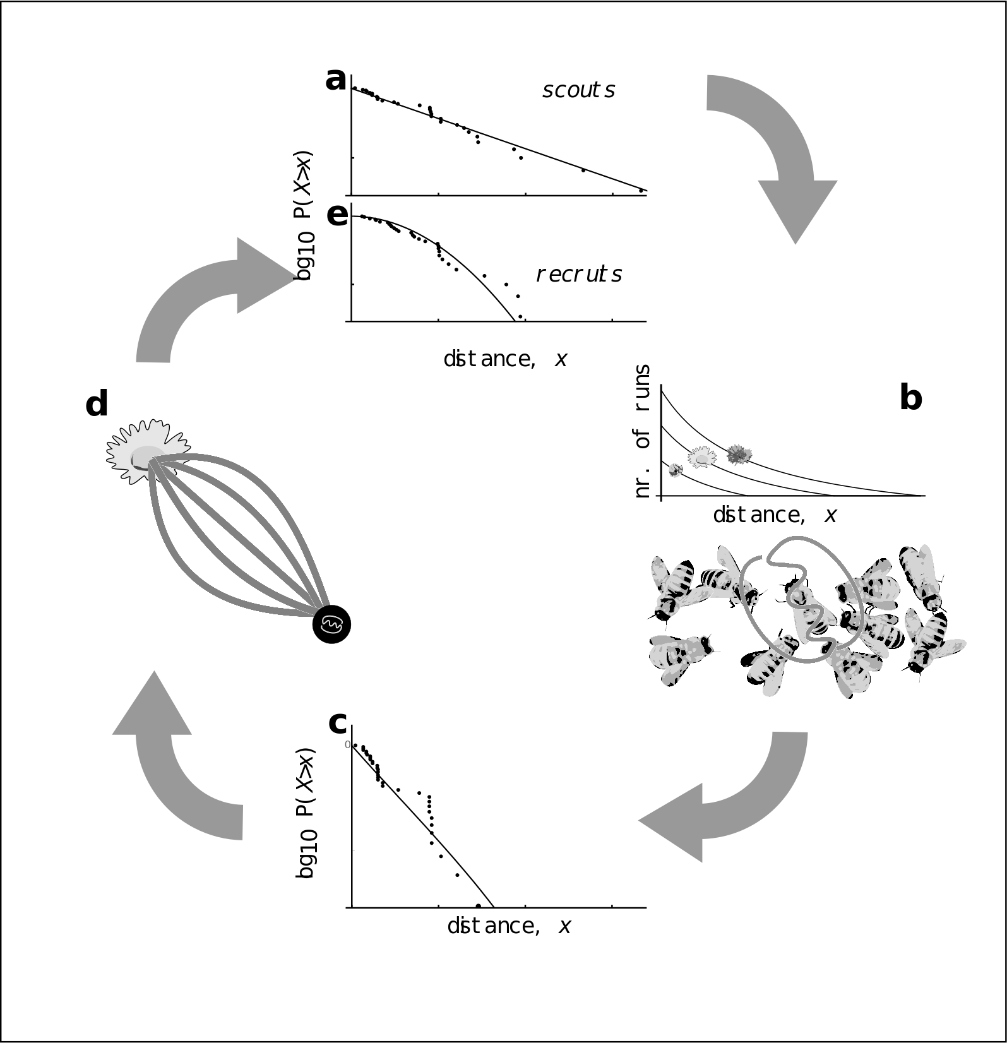

Figure 2: Model of honey bee foraging. Flowers advertised by scouts are distributed exponentially (a). These dances are advertised on the dance floor (b) in relation to their profitability, meaning sampling recruits are biased to the more profitable (and closer) resources (c). After visiting advertised resources, recruits also dance for them leading to higher recruitment (d) which overall skews the distribution of distances reported on the entire dance floor (e).

To evaluate the use of waggle dance information and individual search in honeybee colonies foraging in ‘natural’ landscapes, we analysed an existing dataset of 3378 waggle dance observations from 20 observation hives, recorded between April-September 2017, (previously described in (Samuelson, Schürch, and Leadbeater 2021)). Hives were situated at different locations in South East England (see methods, figure 3A) and were visited every two weeks for a period of 24 weeks. On each visit, two hours of continuous waggle dance data was recorded by training a camcorder onto the dance floor. The footage of the dances was decoded manually ((Couvillon et al. 2012; Schürch et al. 2019) to extract waggle run durations. For each site we fit both the collective and individual models and used model selection to determine which provided the better explanation of the data, and (if the collective model provided a better fit) to quantify the relative use of social information through estimating the parameter p. We calculated the goodness-of-fit using a Kolmorgorov-Smirnov (KS) test to ascertain if the model provided a plausible explanation of the data.

For 17 out of 20 study hives, a model of collective foraging provided a better explanation of the data than one of individual foraging (Fig. 3a). In each of these cases, the collective model had a good fit (using a Kolmogorov-Smirnov statistic, see methods) to the empirical waggle run durations, and for 9 of these sites, the scout model was significantly different to the data (Fig. 3b). The sites shown in Figs 3c-d are representative examples showing the model fits, showing the overall quality of the model fit to the data.

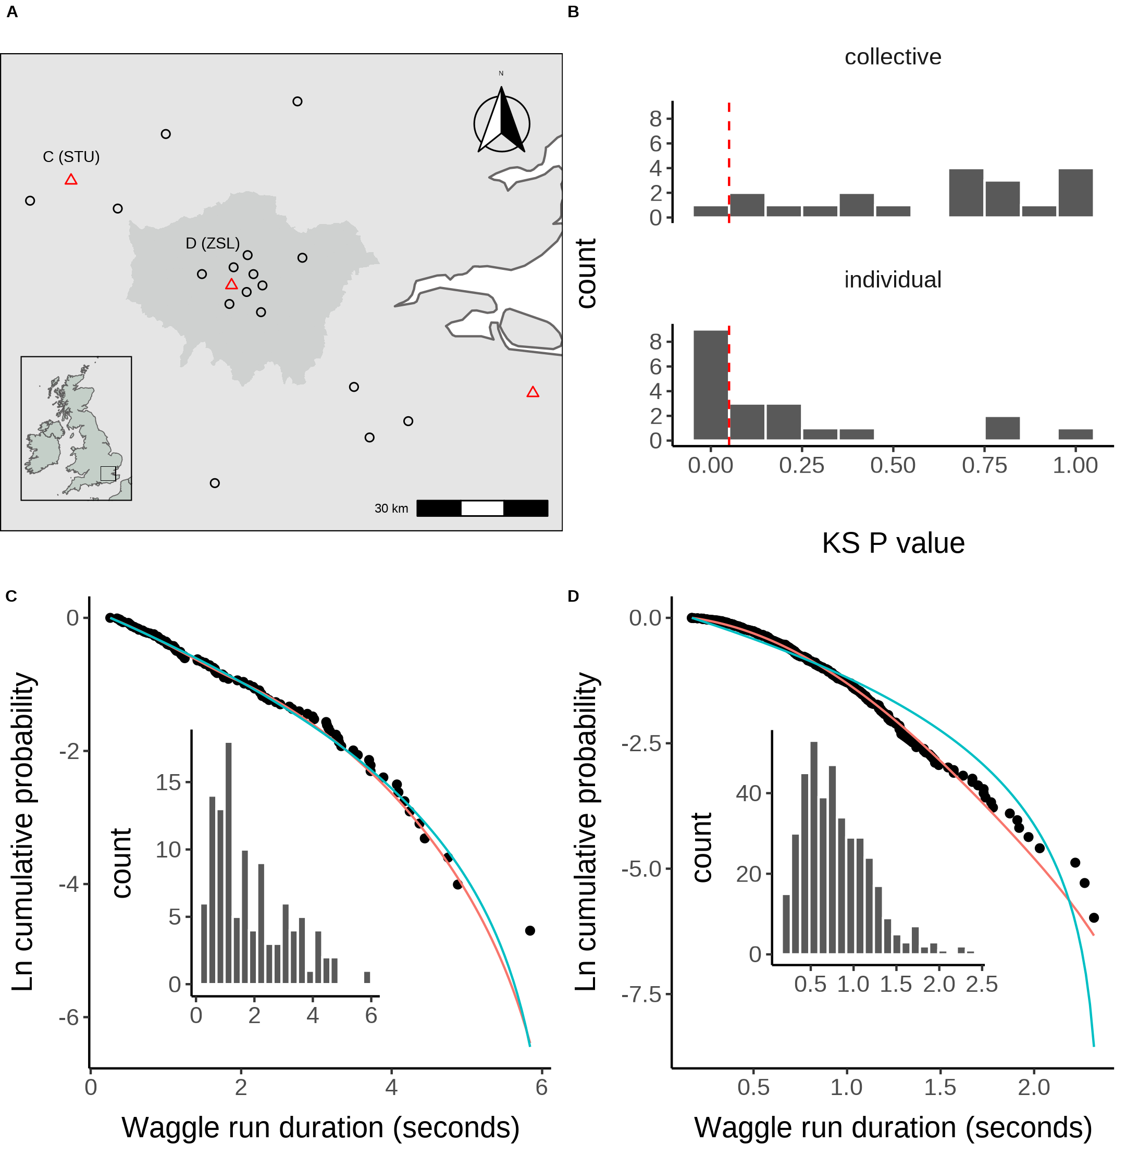

Figure 3. A. Location of study hives in Southern England coloured by which model, collective (black circles) or individual (red triangles) provided the best explanation of the data as indicated by lowest AIC score. Sites STU and ZSL (C & D) are marked. Inset plot shows the location of the sites within the UK. B. Distribution of goodness of fit confidence values for each model fit to waggle run durations from each site. P value is derived from a bootstrapped two-sided KS test comparing the fitted model predictions to the empirical data. The red dashed line marks the significance threshold of 0.05. Values greater than 0.05 indicate no statistically significant difference is observed between the model and the data, indicating the model provides a good fit to the data. C. Model fits to waggle run durations collected from the ZSL hive along with histogram showing distribution. D. Model fits to waggle run durations collected from the STU hive along with histogram showing distribution. Model fits show the compliment cumulative frequency distribution, giving the probability of sampling a value greater than or equal to x.

Our results show that, whilst colony-level foraging mostly use a mixture of scouts and recruits, in some circumstances, colony foraging is best explained by a model of individual foraging. This suggests that in some environments, honey bees actively ignore the waggle dance and instead prioritise the use of private information. Previous empirical studies have shown that individual foragers flexibly alter their use of waggle dance information in response to unrewarding resources (Grüter and Ratnieks 2011; Price et al. 2019). Evaluating how these individual decisions influence the collective, however, has historically been a challenge as it is effectively impossible to track an individuals foraging behaviour over a landscape. As our results show that these individual behaviours accurately describe colony foraging in three different sites, these findings support the idea that these individual behaviours can dominate colony foraging.

Our finding that foraging in some landscapes is more accurately described by ignoring the dance and focusing on private information supports the hypothesis that the dance is used flexibly in response to environmental factors. As the collective model quantifies waggle dance use, the fit of our model provides a tool to evaluate how environmental factors influence waggle dance use, and thus how a colony values social and private information in different environmental circumstances. This allows for comparing waggle dance use across environments.

We compared the estimates of the proportion of scout and recruits for colonies in different environments. Each site used in this study is situated in a landscape comprised of different proportions of land-use types. To evaluate how these different land-use types influenced waggle dance use, we first classified the different land-use types of the area surrounding each site to obtain a standardised land-use profile for the urban and agri-rural environments separately (see methods). As many of the resulting land-use types covaried with each other, we performed a Partial Least Squares (PLS) analysis to determine the principal components that represent combinations of land-use types which explained the most variation in the proportion of scout dances.

In the agri-rural environment one combination of land use types explained ~60% of the variation in the proportion of scouts (beta regression: $R^{2}=0.6$, $ϕ$ = 4.9, p < 0.05, Fig. 4. A). This principal component correlates positively with arable land and negatively with non-agricultural unmanaged green space, built-up areas and water (Fig. 4. B). From the land-use maps coloured by each landscape dominating PC1 (Fig 4) we can see that arable land and built-up areas show the most coverage. As arable land increases whilst unmanged green space and built-up areas decrease, the proportion of individuals prioritising private information increases.

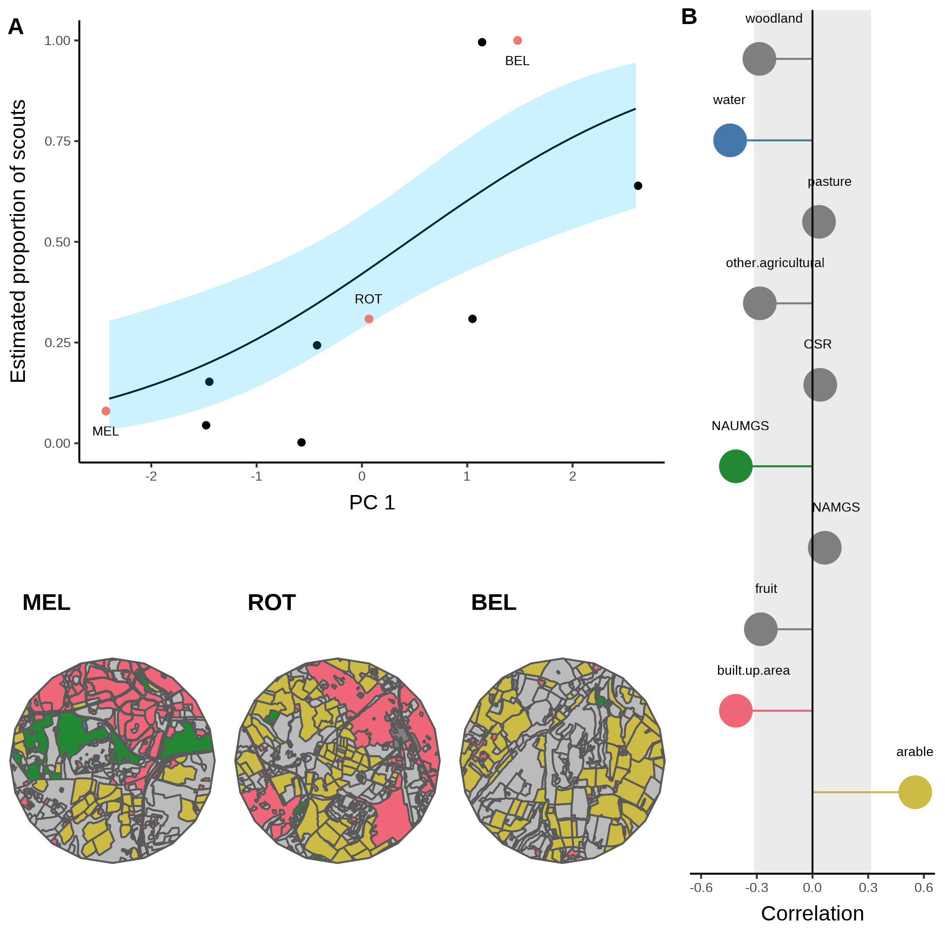

Figure 4. A. Estimated proportion of scouts for each site in the Agri-rural landscape against the first principle component derived from a Partial Least Squares analysis of land-use type. A beta regression shows the relationship (black line) between PC1 and the proportion of scouts, with 95% CI shown by the blue shaded area. B. Loadings for PC1 showing the correlations between PC1 and each land-use type (note NAUMGS stands for Non-agricultural unmanaged green space). All points outside the shaded area significantly contribute to PC1. The colours of these land-use types are shown in the local environment of sites HOR, SWP and CAD (maps in bottom left) chosen as representative sites along the model gradient.

A similar effect is also observed in the urban environment, where a single PC explained ~61% of the variance in the proportion of scouts (beta regression: $R^{2}$ = 0.61, $ϕ$ = 7.4, p < 0.05, Fig. 5. A). This PC correlates positively with continuous central land, dense residential land and water, whilst correlating negatively with sparse residential and amenity grassland (Fig. 5. B). Visualising how waggle dance use is influenced by changes in these land-use types shows that when the landscape is dominated by sparse residential land, as in site HOR, waggle dance use dominates the colonies foraging strategy. However, this reduces as sparse residential land is replaced by continuous central and dense residential lands (Fig. 5)

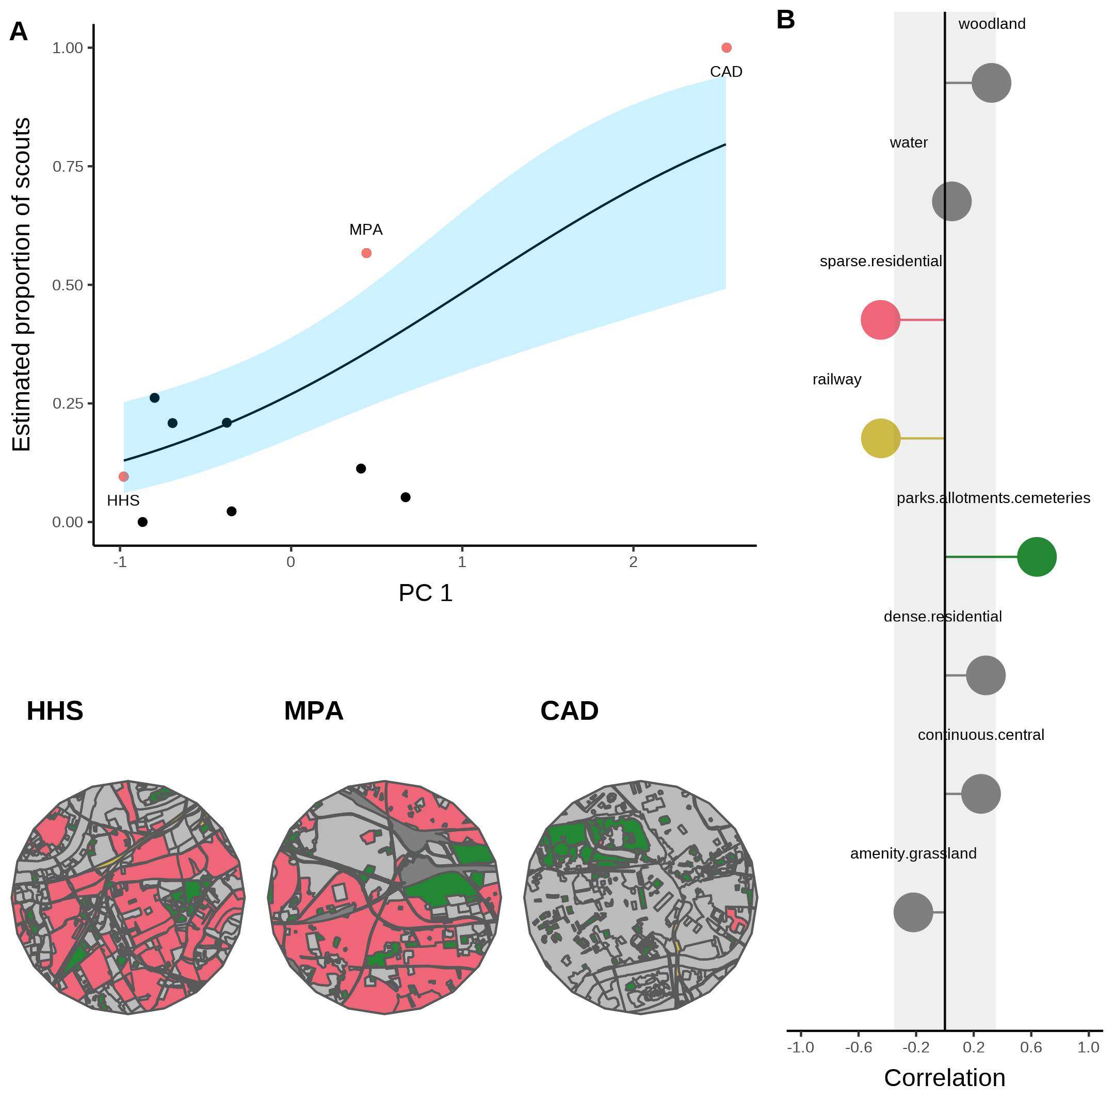

Figure 5. A. Estimated proportion of scouts for each site in the urban landscape against the first principle component derived from a Partial Least Squares analysis of land-use type. A beta regression shows the relationship (black line) between PC1 and the proportion of scouts, with 95% CI shown by the blue shaded area. B. Loadings for PC1 showing the correlations between PC1 and each land-use type. All points outside the shaded area significantly contribute to PC1. The colours of these land-use types are shown in the local environment of sites MEL, SOM and BEL (maps in bottom left) chosen as representative sites along the model gradient.

In agri-rural environments, land-use types which typically associate with resource scarcity correlate positively with a higher proportion of scouts, whilst those which correlate with a higher resource abundance correlate with a lower proportion of scouts. Arable land is typically nutritionally poor for honey bees (ref). On the contrary, non-agricultural unmanaged green space is typically nutrient rich, as are built up areas in agri-rural environments, which often have gardens with ample flowers available for pollinators (ref). These findings indicate that in agri-rural environments, when resources are more abundant and thus easier to find, the collective foraging is used more, presumably to identify the best resources in the environment (ref). Conversely, where resources are more difficult to find, a decreased use of the waggle dance suggests the colony focuses more on individual exploration rather than in trying to locate on the best resources.A similar result is observed for urban environments, where the dependence appears to be driven by the presence of flower rich gardens in residential areas.

The fitting of our model to waggle dance observations provides a novel tool to quantify the relative importance of social and private information in honeybees. Further, by identifying the land-use combinations which most influence variation in the proportion of scouts, our analysis allows us to map the environment along the major axis of honeybee information use and visualise how land-use influences the use of the waggle dance. Our results are in broad agreement with other studies which evaluated foraging performance with and without the dance [Dornhaus et al. (2006); Price2019]. Our results suggest that, even though collective foraging is not always beneficial, that in environments where high quality resources are present, but relatively scarce, collective foraging is being carried out by colonies, suggesting that under these conditions exchanging social information through the waggle dance confers benefits. These benefits of dancing appear to outweigh the costs associated with dancing and could explain why this remarkable behaviour is present in modern-day bees.

The analysis of waggle dance data can make an important contribution to our understanding of social information use and provides a methodology to further evaluate how honey bees use their unique dance language. Recently, technological advances have emerged which enable colony metrics to be collected faster, more accurately and over greater time spans than could be gathered by hand, allowing individuals to be tracked within colonies and theories of individual behaviour to be evaluated in more depth than could have been done previously (Wild et al. 2021). By piecing together the behavioural response of individuals and combining these with landscape analyses, we have found a mathematical description of colony foraging which extends our ability to predict individual behaviour beyond the colony walls and in to the environment. With the advances in the decoding of the waggle dance through automated methods (Wario et al. 2017), we face the prospect of waggle dance data becoming “big data”. Our methodology thus provides a means of analysing such large data sets to inform the debate about the importance of social information, as well as providing useful colony metrics of foraging activity.

# References

Couvillon, Margaret J., Fiona C. Riddell Pearce, Elisabeth L. Harris-Jones, Amanda M. Kuepfer, Samantha J. Mackenzie-Smith, Laura A. Rozario, Roger Schürch, and Francis L. W. Ratnieks. 2012. “Intra-dance variation among waggle runs and the design of efficient protocols for honey bee dance decoding.” *Biology Open* 1 (5): 467–72. <https://doi.org/10.1242/BIO.20121099>.

Dornhaus, Anna, Franziska Klügl, Christoph Oechslein, Frank Puppe, and Lars Chittka. 2006. “Benefits of recruitment in honey bees: Effects of ecology and colony size in an individual-based model.” *Behavioral Ecology* 17 (3): 336–44. <https://doi.org/10.1093/beheco/arj036>.

Frisch, Karl von. 1993. “The Dance Language and Orientation of Bees.” *The Dance Language and Orientation of Bees*, December. <https://doi.org/10.4159/HARVARD.9780674418776/>.

Grüter, Christoph, and Francis L.W. Ratnieks. 2011. “Honeybee foragers increase the use of waggle dance information when private information becomes unrewarding.” *Animal Behaviour* 81 (5): 949–54. <https://doi.org/10.1016/j.anbehav.2011.01.014>.

Grüter, Christoph, Francisca H.I.D. Segers, and Francis L.W. Ratnieks. 2013. “Social learning strategies in honeybee foragers: do the costs of using private information affect the use of social information?” *Animal Behaviour* 85 (6): 1443–9. <https://doi.org/10.1016/J.ANBEHAV.2013.03.041>.

Price, R. I.Anson, N. Dulex, N. Vial, C. Vincent, and C. Grüter. 2019. “Honeybees forage more successfully without the ‘dance language’ in challenging environments.” *Science Advances* 5 (2). <https://doi.org/10.1126/sciadv.aat0450>.

Samuelson, Ash E., Roger Schürch, and Ellouise Leadbeater. 2021. “Dancing bees evaluate central urban forage resources as superior to agricultural land.” *Journal of Applied Ecology*. <https://doi.org/10.1111/1365-2664.14011>.

Schürch, Roger, Keiran Zwirner, Bethany J. Yambrick, Tiffanie Pirault, James M. Wilson, and Margaret J. Couvillon. 2019. “Dismantling Babel: creation of a universal calibration for honey bee waggle dance decoding.” *Animal Behaviour* 150 (April): 139–45. <https://doi.org/10.1016/j.anbehav.2019.01.016>.

Seeley, Thomas D. 1994. “Honey bee foragers as sensory units of their colonies.” *Behavioral Ecology and Sociobiology* 34 (1): 51–62. <https://doi.org/10.1007/BF00175458>.

Sherman, Gavin, and P. Kirk Visscher. 2002. “Honeybee colonies achieve fitness through dancing.” *Nature* 419 (6910): 920–22. <https://doi.org/10.1038/nature01127>.

Sumpter, D. J.T. 2006. “The principles of collective animal behaviour.” *Philosophical Transactions of the Royal Society B: Biological Sciences* 361 (1465): 5–22. <https://doi.org/10.1098/rstb.2005.1733>.

Wario, Fernando, Benjamin Wild, Raúl Rojas, and Tim Landgraf. 2017. “Automatic detection and decoding of honey bee waggle dances.” *PLOS ONE* 12 (12): e0188626. <https://doi.org/10.1371/JOURNAL.PONE.0188626>.

Wild, Benjamin, David M. Dormagen, Adrian Zachariae, Michael L. Smith, Kirsten S. Traynor, Dirk Brockmann, Iain D. Couzin, and Tim Landgraf. 2021. “Social networks predict the life and death of honey bees.” *Nature Communications 2021 12:1* 12 (1): 1–12. <https://doi.org/10.1038/s41467-021-21212-5>.